Memo

Date: May 2000
To: John Sherriff, Richard Lewis, Fernley Dyson, Michael Moscoso, David Port, Sally Beck

From: James New
Re: UK Power – April 2000 Curve Validation and Profit and Loss Report
The purpose of this memorandum is to summarise our review of the UK Power Curves used as at the 28th April 2000 and analyse the reported profits of the book.

A- Executive Summary
Having reviewed the UK Power Curves, we conclude the curves are constructed with an objective methodology, using the latest data, where available, and are consistent with relevant market information. Subject to the limitations we have found as detailed below, the value of the positions, at the 28th April, is not materially misstated. The loss for the month of April was £2.3m (March £31.8m profit) and the total net assets were £231.3m (March £233.7m).
Of the loss of £2.3m, approximately £1.1m was due to forward delta - £2.5m profit on LOLP, and approximately £(1.6)m for Summer 2000, £(3.0)m for Winter 2000 and £1.0m for Summer and Winter 2001.
The liquid parts of the curve agree to the broker quotes. Further analysis can be seen in Section 2.1.
Cash realised in the month was an outflow of £0.7m, (March £4.1m inflow) for the UK Power book. The number of trades done during April were 385, compared to 557 in March.
During the review period Enron sold its equity in the 790 MW Sutton Bridge power station to EdF. The CTA was novated to EdF which transfers the gas and power commodity positions from the Sutton Bridge project to a 3td-party toller. A new 6 month 700 MW purchase from EdF was recognised to provide EdF a traditional hedge for Sutton Bridge’s power production.
The transaction resulted in a significant shorting of Enron’s UK Power position by approx 49.9Twhrs which required board approval for short term risk limit increases.
Enron Online (EOL) have done 84 trades during April (165 during March). Entergy were still the counterparty most frequently traded on Online with 35 trades in the period – Aquila Energy Limited also used EOL for the first time this month - a sale of Winter 2000 20MW Base Load. The value of the trades for EOL at 28th April was £(9.6)m, (31st March £(19.0)m) - in general during April Enron has taken a long position through EOL of approximately 1.0 TWh.

B - Curve Validation

1. Methodology
The curves have been reviewed using the following criteria, and have been split in the same way as in the UK Power Market Forward Curves Document (January 2000).
- Broker Quote Variance - Front End
- Historical Trades / Press reports - Middle
- Curve Construction - Back End

2. Review – Power Delta

2.1 Broker Quote Variance – Front End (June 2000 – March 2002)
Broker prices that were available for different load shapes and time periods were compared with the curve as at 28th April 2000.The total implied overstatement of profits was estimated to be £103k (March 2000 £466k understated) which was considered immaterial, and no P&L adjustments have been made.
The curve for May 2000 and June 2000 are 34p above and 23p above the broker quotes respectively, giving an estimated understatement of profits of £(148)k and £(132)k respectively. The Enron curve values for the remaining months / seasons showed a variance of 34p over broker quotes for Quarter 3 of 2000, when compared to the prices obtained. This variance gives an over valuation of £384k, resulting in a total of £103k overstatement. Full details are included in Appendix 1.
This method of validation is only relevant for the period for which quotes were available. Therefore, this method only verifies the curve for the first 18 months.
The analysis of the broker quotes for the front end of the curve over the quarter has shown that the traders curves have been consistent. The large movements in the market have been evidenced via the broker quotes, and matched daily to the Enron curves.

2.2 Historical Trades – Middle ( 2002 – 2010)
There were no trades completed by Enron for this period in April. The latest trades for this period were done during September when there were a series of peak winter swaps and swaptions and summer peak swaptions for the next 5 years to September 2005 with National Power which greatly reduced our 5 year peak position plus a 10 year baseload deal with Magnox. The most recent long-term trades done by Enron are the Magnox deal (10 year baseload 50MW ) done on 21st Sept 1999
During March there has been a firm offer on a 10 year swap via a broker quoted which caused the curve to be marked down.
The longest external trades done by Enron in April were for Winter 2001 / 02.

2.3 Curve Construction – Back End (2010-2025)
The back end of the curve did not move during April. Over the long term the curve is determined by considering the long-term cost of producing electricity. Using the Gas Forward curve and the latest economics for a 1200MW plant it is possible to create a forward cost of power from the latest CCGT i.e. the most efficient plant available. (The method is discussed at greater length in the UK Power Market Forward Curves Document by Power Risk Management, January 2000).

3 Review – Other Risk Variables
Interest rate risk is not reviewed as all P&L derived from this is passed to the Interest rate book.
The present value of options and swaptions at the end of April was £(28.7)m (March £(28.0)m) with maturities going out to February 2005

There are no market quotes for implied volatilities. Trades are compared to volatilities implied from option trades completed or reported in the month to ensure consistency. Volatility ladders were calculated to quantify the sensitivity of the portfolio to volatility moves. Enron is now net long volatility. For a baseload volatility move of +/- 1% the implied P&L would be a profit of £111k / loss of £131k respectively (March profit of £239k / loss of £199k).
There were 22 swaptions / options traded this month by Enron (March 6). The volatility on these trades was on average 14.5% (March 11.0%). Latest trades for Winter 2000 were at 15%
There were no swaptions traded during April 2000 which were not completed by Enron.
There are no market quotes for LOLP. There is currently a long position of 3.4 TWh out to September 2000, and the curve as at 28th April 2000 values the position at £2.71/MWh. This would suggest a maximum loss on our current position of £9.21m assuming no LOLP throughout the Summer

C – P&L Commentary

1. Mark to Market changes
The P&L for April was £(2,319,978). The main changes for April were:
- Loss of £(7.98)m on the change in value of the April intra-month positions. This was largely due to price increases in PPP for the period 10-14TH April 2000.
- Origination on LOLP Call option of £1.5m with National Grid Company plc
- Reversal of Sutton Bridge extension option in the period resulted in £1.8m profit.
- The increase in prudency reserves of £57.2m over the month was largely due to monthly increase in short position upon the sale of Sutton Bridge. This drove an increase in calculated reserve of £11.4m on PPP. In an addition a reserve of £46m was also recognised upon the sale of Sutton Bridge.
- Curve shift, originations and rebookings of £59.6m. The forward delta for April was £(1.1)m which was mainly due to losses of £3.6m on PPP, and gain of £2.5m on LOLP positions. The Energy Trends position did not change in the review period. An interbook. A transfer of prudency from the Spread Option Book of £58.9m was recognised in the period.

2. Realised Profit
The realised loss for April was £0.69m (March £4.13m gain).
- PPP £(2.8)m loss (March £3.88m gain)
- SMP £0m gain (March £0.23m gain)
- LOLP £2.1m gain (March £0.02m gain)
The total realised gain for the four months to April was £15.4m

3. Prudency
Total prudency at 28th April was £77,637,219 (March £20,443,527). Prudency is calculated by assigning a factor to the absolute MWhs per month for each portfolio.
For PPP it is 10p in the first 6 months, 15p in the second 6 months, 25p in the third six months, 30p in the fourth 6 months and 33p from 2 years onwards for each MWh. For LOLP it is 56p for each MWh. For energy trends deals it is 75p for the first 6 months, 100p for the second 6 months, 135p for the next 12 months and 175p for 2 years onwards for each MWh.
The general prudency reserve of £7,389,740 did not change in the review period.

The reserves are summarised as follows :

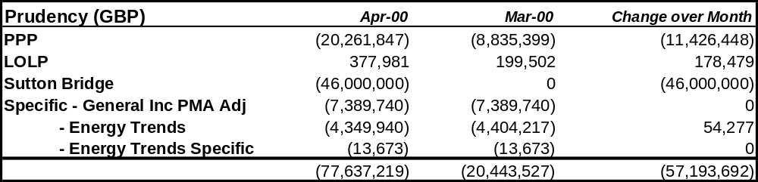

4. Monthly Curve Moves

During the month the forward curves moved as per the graphs in Appendix 2, 3 and 4. The Summer 2000 Peak / Off Peak spread for Summer 2000 narrowed in the period, while the spread for Winter widened.

Baseload prices for Summer 2000 moved up by £0.02/MWh on average, and Winter 2000 moved down by £0.37/MWh on average. Summer 2001 peaks moved down £0.04/MWh and off peaks moved down £0.14/MWh. Winters from 2001 moved down £0.02/MWh. There was no change for Summers from 2002 forward.

There is currently a long LOLP position for Summer 2000 and prices moved up during April by £0.19/MWh for that period.

The 3 year October baseload price has moved from £17.94/MWh at the end of March to £17.91/MWh at the end of April. The 5 year October baseload price has moved from £18.06/MWh at the end of March to £18.04/MWh at the end of April; the 10 year October baseload price has moved from £18.46/MWh at the end of March to £18.45/MWh at the end of April.

The intramonth curve moved up consistently during April to generate approximately £(7.8)m loss. The exact reasons for this are hard to determine, but the general opinion is that it may be due to announcements of plant being taken off lie (especially by TXU), a back lash from the low prices seen the previous month and the colder wet weather seen over recent weeks.

5. Energy Trends Electricity

The current MTM of the Energy Trends position as at 28th April was £61,178,093 (March £61,002,065).
A full explanation of the curve construction may be found in the Power Risk Management Energy Trends Curve Construction Document (revised April 2000).

6. Summary of Current Position
There were 385 new deals in the month (March 557) and over the month the total weighted short position increased by 38.5 TWh (March short position decreased by 2.6 TWh). The main changes in position were :
- Summer 2000 was long by 762MW Peaks and 542MW Off Peaks on average. Q3 2000 trades shorted 405MW Peaks / long 121MW Off Peaks on average.
- Shorting of position upon the sale of Sutton Bridge by approx 49.9Twhrs.
- The longest dated external trade was for Winter 2001 / 2002.
The un-weighted discounted positions are broken down as follows :
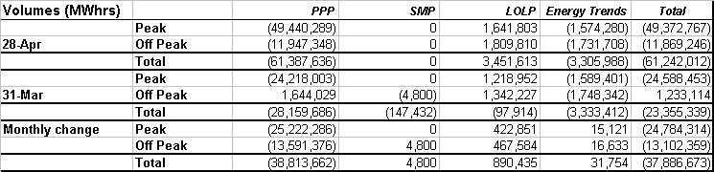
Graphs, by EFA slot, of the un-weighted volumes of PPP, SMP and LOLP in MWh are presented in Appendix 5 at January 2000.

7. Value at Risk
The 1 day value at risk at 28th April was £8,766,050 using a 5% 1 tail confidence interval (March £4,262,826). This rise was again due to positional increase following the sale of Sutton Bridge.

Appendix 1.
Broker Quotes Comparison
Appendix 2.
Curve shift impact and curve movement for PPP for April 2000.
Appendix 3.
Curve shift impact and curve movement for LOLP for April 2000.
Appendix 4.
Curve shift impact and curve movement for SMP for April 2000.
Appendix 5.
Delta Volumes as at 28th April 2000.
Appendix 6.
P&L analysis split.

Appendix 7.
Peak / Off Peak / Baseload monthly curve shift and P&L analysis.

Appendix 8.

A Graph to show amounts Settled per month and the book Profit for the month.

Appendix 9.

Analysis of forward delta by period

